TECHNICAL TEST - FULLSTACK DEVELOPER
This technical test is designed to evaluate the candidate’s skills in C# language and angular framework. The test will consist of implementing a REST API using an existing data model in database and use it as data provider for the client application
Instructions
- The time to execute the test is around 1,30/2h
- The test will be implemented using Visual Studio 2019, Visual Code and .NET Core 3.1
- Last LTS node version
- In the same solution folder, you can find a json to import new collection into postman to see the REST API requests to implement
- You can see the data model using Microsoft SQL Server Management Studio with the next connection parameters:
  - Server: qbi-dev-sql-server.database.windows.net
  - DataBase: TechnicalTestDB
  - User: TechnicalTestUser
  - Password: 7wACDD4%55?pM%7P
- The solution of the test has three projects with the next structure:
  - Core
    - Application layer
      - This layer contains business validation rules
      - It connects WebApi layer with data layer
    - Data layer
      - It contains repositories to access data
  - WebApi
    - REST API project
  - UI
    - Angular client application
Test
Based on the following database model:
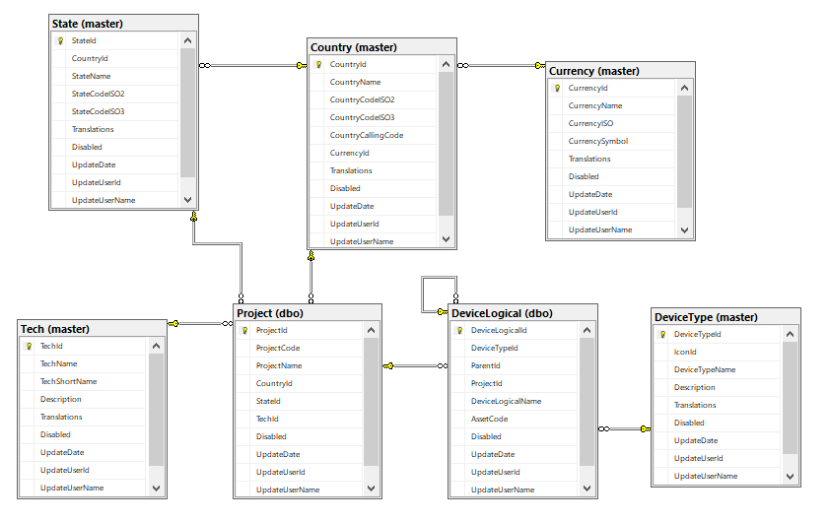
- Change the necessary code to return country, state and tech details in the projects request (GET/project). The response should be something like this:
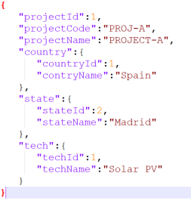
- Create REST API methods for Device entity (including all the structures you need to implement the desired solution):
  - Get Devices: This method should return all devices stored in database. Additionally, you can add a parameter to filter the query by “DeviceType” field.
  - Get Device: This method should return a concrete device with all possible fields.
  - Create Device: This method should create a new Device in database.
  - Update Device: This method should update an existing Device in database.
  - Delete Device: This method should remove an existing Device in database.
- The steps you must follow for the angular test are in the home page of the client application

